INDUSTRY MATERIAL DETAILS:-

USING VB.NET AS FRONTEND AND

SQL ASA BACKEND

Signin:-

Dim con As New SqlConnection

Dim cmd As New SqlCommand

con.ConnectionString = "Data Source=.\sqlexpress;Initial Catalog=project;Integrated Security=True"

Dim objcon As SqlConnection = Nothing

Dim objcmd As SqlCommand = Nothing

Try

objcon = New SqlConnection("Data Source=.\sqlexpress;Initial Catalog=project;Integrated Security=True")

objcon.Open()

Dim stmt As String = "select \* from register where email ='" & email.Text & "' AND password ='" & password.Text & "' "

objcmd = New SqlCommand(stmt, objcon)

Dim reader As SqlDataReader = objcmd.ExecuteReader

If reader.Read Then

MessageBox.Show("signin successfully")

Me.Hide()

form3.show()

Else

email.Clear()

password.Clear()

End If

Catch ex As Exception

MsgBox("MSSQL ERROR")

End Try

Signup:-

Try

Dim con As New SqlConnection

Dim cmd As New SqlCommand

Dim dr As SqlDataReader

con.ConnectionString = "Data Source=.\sqlexpress;Initial Catalog=project;Integrated Security=True"

con.Open()

cmd.Connection = con

cmd.CommandType = CommandType.Text

cmd.CommandText = "select \* from register where email='" & email.Text & "' "

dr = cmd.ExecuteReader

If dr.HasRows Then

MsgBox("Email Id Already Registered", MsgBoxStyle.Critical)

con.Close()

Else

con.Close()

con.Open()

cmd = New SqlCommand("INSERT INTO register values('" & fname.Text & "','" & lname.Text & "','" & email.Text & "','" & password.Text & "')", con)

If (fname.Text = "" And lname.Text = "" And email.Text = "" And password.Text = "") Then

MessageBox.Show("Please enter the details")

Else

cmd.ExecuteNonQuery()

MsgBox("Succerssfully Registered.", MsgBoxStyle.Information, "Success")

Me.Hide()

Form2.Show()

fname.Clear()

lname.Clear()

email.Clear()

password.Clear()

End If

con.Close()

End If

con.Close()

Catch ex As Exception

MsgBox("Error")

inserting into database:-

Dim command1 As New SqlCommand("Insert into table1(materialcode,materialcategory,materialdescription,stockonhand,value,safteystock)values(@materialcode,@materialcategory,@materialdescription,

@stockonhand,@value,@safteystock)", con1)

command1.Parameters.Add("@materialcode ", SqlDbType.VarChar).Value = TextBox1.Text

command1.Parameters.Add("@materialcategory ", SqlDbType.VarChar).Value = TextBox2.Text

command1.Parameters.Add("@materialdescription ", SqlDbType.VarChar).Value = TextBox3.Text

command1.Parameters.Add("@stockonhand ", SqlDbType.VarChar).Value = TextBox4bType.VarChar).Value = TextBox3.Text

command1.Parameters.Add("@value ", SqlDbType.VarChar).Value = TextBox5bType.VarChar).Value = TextBox3.Text

command1.Parameters.Add("@safteystock ", SqlDbType.VarChar).Value = TextBox6alueckonhandbType.VarChar).Value = TextBox3.Text

materialcodear).Value = TextBox1

materialcodear).Value = TextBox1Dim memstr As New MemoryStream

PictureBox1.Image.Save(memstr, PictureBox1.Image.RawFormat)

command1.Parameters.Add("@itemimage", SqlDbType.Image).Value = memstr.ToArray

If con1.State = ConnectionState.Closed Then

con1.Open()

End If

command1.ExecuteNonQuery()

MessageBox.Show("inserted successfully")

con1.Close()

bind1()

TextBox1.Text = ""

TextBox2.Text = ""

TextBox3.Text = ""

TextBox4.Text = ""

TextBox5.Text = ""

TextBox6.Text = ""

Private Sub bind1()

Dim command1 As New SqlCommand("Select \* from table1 order by id desc", con1)

Dim adapter As New SqlDataAdapter(command1)

Dim table As New DataTable()

adapter.Fill(table)

DataGridView1.AllowUserToAddRows = False

DataGridView1.RowTemplate.Height = 90

Dim pic1 As New DataGridViewImageColumn

DataGridView1.DataSource = table

pic1 = DataGridView1.Columns(7)

pic1.ImageLayout = DataGridViewImageCellLayout.Stretch

End Sub

, choose the image from your syatem

Dim openfiledialog1 As New OpenFileDialog

openfiledialog1.Filter = "images|\*.jpeg;\*.png;\*.gif;\*.bmp"

If openfiledialog1.ShowDialog = Windows.Forms.DialogResult.OK Then

PictureBox1.Image = Image.FromFile(openfiledialog1.FileName)

End If

Datagridview viewer

TextBox1.Text = DataGridView1.CurrentRow.Cells(1).Value

TextBox2.Text = DataGridView1.CurrentRow.Cells(2).Value

TextBox3.Text = DataGridView1.CurrentRow.Cells(3).Value

TextBox4.Text = DataGridView1.CurrentRow.Cells(4).Value

TextBox5.Text = DataGridView1.CurrentRow.Cells(5).Value

TextBox6.Text = DataGridView1.CurrentRow.Cells(6).Value

Dim img As Byte()

img = DataGridView1.CurrentRow.Cells(7).Value

Dim memstr As New MemoryStream(img)

PictureBox1.Image = Image.FromStream(memstr)

Download the material image from the database

Dim sfdpic As New SaveFileDialog()

Dim path As String = "C:\Users\lenovo\Database Retrieve Images "

Dim dir As String = System.IO.Path.GetDirectoryName(path)

Dim title As String = "code a minute-ibasskung."

Dim btn = MessageBoxButtons.YesNo

Dim ico = MessageBoxIcon.Information

Try

If Not System.IO.Directory.Exists(dir) Then

System.IO.Directory.CreateDirectory(dir)

End If

With sfdpic

.Title = "Save As"

.Filter = "jpg,jpeg images|\*.jpg;\*.jpeg|png image|\*.png|bmp image|\*.bmp"

.AddExtension = True

.DefaultExt = "jpg"

.FileName = "mypicyure.jpg"

.ValidateNames = True

.OverwritePrompt = True

.InitialDirectory = dir

.RestoreDirectory = True

If .ShowDialog = DialogResult.OK Then

If .FilterIndex = 1 Then

PictureBox1.Image.Save(sfdpic.FileName, Imaging.ImageFormat.Jpeg)

ElseIf .FilterIndex = 2 Then

PictureBox1.Image.Save(sfdpic.FileName, Imaging.ImageFormat.Png)

ElseIf .FilterIndex = 3 Then

PictureBox1.Image.Save(sfdpic.FileName, Imaging.ImageFormat.Bmp)

End If

Else

Return

End If

End With

Catch ex As Exception

MessageBox.Show("error:saving image failed->>" & ex.Message.ToString())

Finally

sfdpic.Dispose()

End Try

Filter

Dim command1 As New SqlCommand("Select \* from table1 where name like'%'+@parm1+'%'", con1)

command1.Parameters.AddWithValue("@parm1", TextBox2.Text)

Dim adapter As New SqlDataAdapter(command1)

Dim table As New DataTable()

adapter.Fill(table)

DataGridView1.AllowUserToAddRows = False

DataGridView1.RowTemplate.Height = 90

Dim pic1 As New DataGridViewImageColumn

DataGridView1.DataSource = table

pic1 = DataGridView1.Columns(12)

pic1.ImageLayout = DataGridViewImageCellLayout.Stretch

Signin page

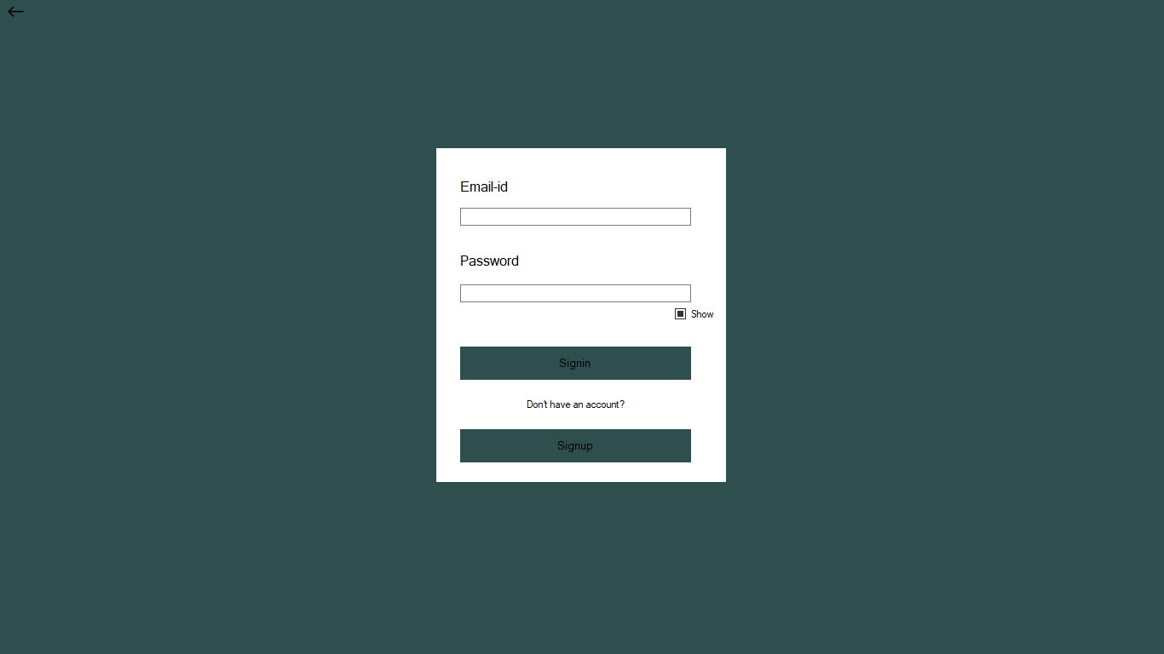

Signup page

